

**Accommodation / Transportation Guide**

**Hotel:**

* **The View Hotel**
* **Golden Tulip FARAH**
* **Rive Hotel**
* **Rihab Hotel**
* **Yasmine club Hotel**

**Airports:**

* Rabat (RBA): Rabat-Salé Airport (10 Km from the Capital city Rabat)
* Casablanca (CMN): Mohammed V International Airport (120km from the Capital City Rabat)

**Conditions for Hotel reservations:**

1. deadline reservation: **August 31st**, 2017
2. The payment method: bank transfer or cash on arrival

**Account Details:**

FEDERATION ROYALE MAROCAINE DE TAEKWONDO

BANK NAME: BMCE BANK

SWIFT: BMCEMAMC

IBAM: 011 810 00 00 14 210 01 04898 90

**Conditions for transportation reservation:**

1. Deadline reservation: **August 31st**, 2017
2. The ground transportation (Hotel - Venue- Hotel) will be provided free of charge ONLY for the teams who have reserved the hotel through the Organizing Committee.
3. The transportation (Airport - Hotel - Sport Venue, Sport Venue -Hotel - airport) will be provided free of charge ONLY for teams who has reserved the hotel through the Organizing Committee.
4. the contact person in charge of reservation:

Mr.LABLAN : +212 6 61 06 99 03 / +212 6 61 19 46 38

[frmtk@hotmail.com](mailto:frmtk@hotmail.com)

mtu.president@gmail.com



**Transportation**

Rabat–Salé Airport

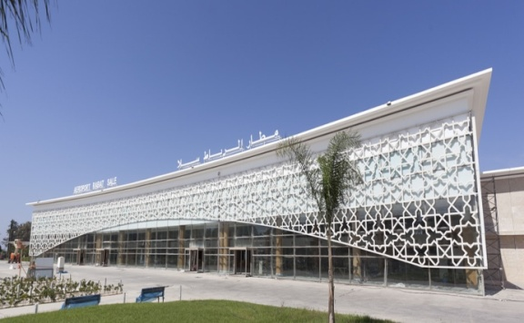

Rabat,Salé Airport is an [international airport](https://en.wikipedia.org/wiki/International_airport) located in the city of [Salé](https://en.wikipedia.org/wiki/Sal%C3%A9), also serving [Rabat](https://en.wikipedia.org/wiki/Rabat), the [capital city] of [Morocco](https://en.wikipedia.org/wiki/Morocco) and of the [Rabat-Salé-Kénitra](https://en.wikipedia.org/wiki/Rabat-Sal%C3%A9-K%C3%A9nitra) region. It is a joint use public airport, also hosting the First Air Base of the [Royal Moroccan Air Force](https://en.wikipedia.org/wiki/Royal_Moroccan_Air_Force). The airport is located about 7 kilometers (5 mi) east-northeast of [Rabat](https://en.wikipedia.org/wiki/Rabat) the capital city of Morocco country and from the sport venue.

Mohammed V International Airport

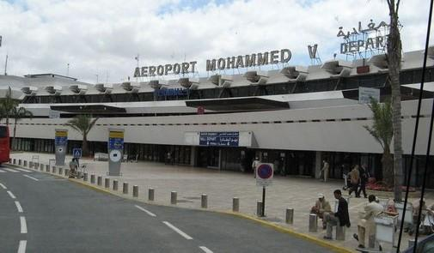Mohammed V International Airport (French: Aéroport international Mohammed V, [Arabic](https://en.wikipedia.org/wiki/Arabic_language): مطار محمد الخامس الدولي‎‎, Matar Muhammad al-Khamis ad-Dowaly, [IATA](https://en.wikipedia.org/wiki/International_Air_Transport_Association_airport_code): CMN, [ICAO](https://en.wikipedia.org/wiki/International_Civil_Aviation_Organization_airport_code): GMMN) is an [international airport](https://en.wikipedia.org/wiki/International_airport) serving [Casablanca](https://en.wikipedia.org/wiki/Casablanca), [Morocco](https://en.wikipedia.org/wiki/Morocco). Located in [Nouaceur Province](https://en.wikipedia.org/wiki/Nouaceur_Province), it is operated by [ONDA](https://en.wikipedia.org/wiki/ONDA_(Morocco))(National Airports Office). With just under 8 million passengers passing through the airport in 2014, it was the busiest airport in [Morocco](https://en.wikipedia.org/wiki/Morocco) and the fourth busiest in [Africa](https://en.wikipedia.org/wiki/Africa). In August 2014, ONDA reported a year-on-year increase of 7.28% passenger traffic, to 918,238. The airport serves as hub for Morocco's [flag carrier](https://en.wikipedia.org/wiki/Flag_carrier) [Royal Air Maroc](https://en.wikipedia.org/wiki/Royal_Air_Maroc), [Jetairfly](https://en.wikipedia.org/wiki/Jetairfly), [Air Arabia Maroc](https://en.wikipedia.org/wiki/Air_Arabia_Maroc) and [RAM Express](https://en.wikipedia.org/wiki/RAM_Express).

The airport is about 90 Km far from the sport venue.



**Rabat 2017 World Taekwondo Grand Prix Series**

**Arrival & Departure Form**

|  |
| --- |
| **TO**: Organizing Committee  THE ROYAL MOROCCAN TAEKWONDO FEDERATION  Av, ibnSina, siege des Federations, Rabat, Agdal, Morocco |
| Tel: +212 5 37 67 01 39 |
| Fax: +212 5 37 67 02 06 |
| [frmtk@hotmail.com](mailto:frmtk@hotmail.com)  [mtu.president@gmail.com](mailto:mtu.president@gmail.com) |

Please fill in the following enclosed form for your arrival and departure so we can handle your team at both airport s straight to the Hotel.

* Transportation provided only for teams with hotel reservations Organized by Organizing Committee.

**Travel datesofteam:**

**Country/Team**

**……………………………………………………………………………**

**Representativename (MNA)**

**……………………………………………………………………………**

**Tel.:……………………………………………Mobile:………….…………………..…**

**Fax:…………………………………………E-mail:……………….………………………**

**ARRIVAL**

|  |  |  |  |  |
| --- | --- | --- | --- | --- |
| Airport | DATE | ARRIVAL TIME | FLIGHT NO. &AIRLINE COMP. | NUMBER OF PERSONS |
|  |  |  |  |  |

**DEPARTURE**

|  |  |  |  |  |
| --- | --- | --- | --- | --- |
| Airport | DATE | DEPARTURE TIME | FLIGHT NO. &AIRLINE COMP. | NUMBER OF PERSONS |
|  |  |  |  |  |

Signature of The MNA President

**Rabat 2017**

**Hotel Reservation Form**

**Name of MNA: ……………………………………………………………………………………………..**

**The View Hotel ***** STARDistance to:Venue4.8KM, RBA Airport 20.7KM, CMN Airport 114KM**

|  |  |  |  |  |  |  |
| --- | --- | --- | --- | --- | --- | --- |
| **Room Type** | **Arrival Date** | **Departure Date** | **No. of**  **NIGHTS** | **Number of**  **Rooms** | **Pricing**  **Per Night**  **Per Person** | **Total**  **Amount** |
| **Single** |  |  |  |  | 210 Euro |  |
| **Double** |  |  |  |  | 120 Euro |  |
| **TOTAL** |  |  |  |  |  |  |

**Golden Tulip Farah Hotel *****STARDistance to: Venue 10.5KM, RBA Airport 8.8KM,CMN Airport120KM**

|  |  |  |  |  |  |  |
| --- | --- | --- | --- | --- | --- | --- |
| **Room Type** | **Arrival Date** | **Departure Date** | **No. of**  **NIGHTS** | **Number of**  **Rooms** | **Pricing**  **Per Night**  **Per Person** | **Total**  **Amount** |
| **Single** |  |  |  |  | 125 Euro |  |
| **Double** |  |  |  |  | 75 Euro |  |
| **TOTAL** |  |  |  |  |  |  |

**Rive Hotel **** STAR Distance to: Venue 10KM, RBA Airport 8.6KM, CMN Airport 120KM**

|  |  |  |  |  |  |  |
| --- | --- | --- | --- | --- | --- | --- |
| **Room Type** | **Arrival Date** | **Departure Date** | **No. of**  **NIGHTS** | **Number of**  **Rooms** | **Pricing**  **Per Night**  **Per Person** | **Total**  **Amount** |
| **Single** |  |  |  |  | 100 Euro |  |
| **Double** |  |  |  |  | 70 Euro |  |
| **TOTAL** |  |  |  |  |  |  |

**RIHAB Hotel **** STAR Distance to: Venue 12.1KM, RBA Airport 8.9KM, CMN Airport 122KM**

|  |  |  |  |  |  |  |
| --- | --- | --- | --- | --- | --- | --- |
| **Room Type** | **Arrival Date** | **Departure Date** | **No. of**  **NIGHTS** | **Number of**  **Rooms** | **Pricing**  **Per Night**  **Per Person** | **Total**  **Amount** |
| **Single** |  |  |  |  | 80 Euro |  |
| **Double** |  |  |  |  | 60 Euro |  |
| **TOTAL** |  |  |  |  |  |  |

**Yasmine Hotel Club **** STAR Distance to:Venue 7.5KM, RBA Airport 24.7KM, CMN Airport106KM**

|  |  |  |  |  |  |  |
| --- | --- | --- | --- | --- | --- | --- |
| **Room Type** | **Arrival Date** | **Departure Date** | **No. of**  **NIGHTS** | **Number of**  **Rooms** | **Pricing Per Night Per Person** | **Total**  **Amount** |
| **Single** |  |  |  |  | 70 Euro |  |
| **Double** |  |  |  |  | 50 Euro |  |
| **TOTAL** |  |  |  |  |  |  |

**Note: FOR ALL HOTELS: All price are in EURO or MAD equivalence currency and are per person and per night included local taxes and ONLY BREAKFAST.**

***Important Notice: This document must be returned to the Organizing Committee NO LATER THAN* August the 31st, 2017 *toensure appropriate transportation arrangements for your team****.*