Please send this form to the WT Education Dept. to (education@worldtaekwondo.org) by no later than November 10, 2020
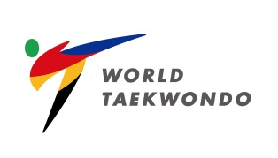 |  | Please attach your Photo here  (or send in a separate file)
Name | Last Name: (Family) | First Name:
Residence | (Which MNA or CU belongs to) | Date of Birth | (DD/MM/YEAR)
Position | (on your MNA or CU)
Nationality |  | Language Skills
Mobile Number | (including national code)
E-mail
Recommendation by  President of pertinent Member National Associations or Continental Unions | Name: | Signature:
I hereby submit my application to attend the:
Level I / WT Technical Delegate Certification Course – Kyorugi (Online Education) conducted by WT (24-25 Nov. 2020)
Date:
Signature:

