Please send your completed application form to World Taekwondo by using E-mail account: (registration@worldtaekwondo.org) – The application deadline is November 1, 2019.
Application for the WT IR Seminar (RUS)  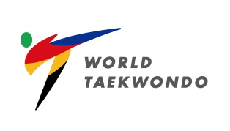 |  |  | Please  Attach your  Photo here
Name | Last Name: (Family) | Name:
Residence  (MNA) | Where you belongs to: | Gender |  | M( ) / F ( )
Nationality |  | Date of Birth |  | (MM/DD/YEAR)
Occupation
Kukkiwon Dan Grade |  | Date of Issue  (MM/DD/YEAR)
Kukkiwon Dan
Certificate No.
National Referee Certificate No.  (for Kyorugi Only) |  | Date of Issue  (MM/DD/YEAR)
Mobile Number | ( )
E-mail
Valuable  Shipping Address | For International Shipping  (English ONLY)
Recommendation by  Member National Association President  (ONLY!!) | Name: | Signature:
I hereby submit my application to attend the:
The 115th International KYORUGI Referee Seminar to be conducted by WT.
The 47th International POOMSAE Referee Seminar to be conducted by WT.

Date:
Signature:

