Please send your completed application form to World Taekwondo by using E-mail account: (registration@worldtaekwondo.org) – The application deadline is March 1, 2019.
Application for PARA Kyorugi Referee Seminar (TUN)  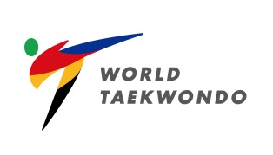 |  |  | Please  Attach your  Photo here
Name | Last Name: (Family) | Name:
Residence  (MNA) | Where you belongs to: | Gender |  | M( ) / F ( )
Nationality |  | Date of Birth |  | (MM/DD/YEAR)
Occupation
Kyorugi
I.R. Number
Mobile Number | ( )
E-mail
Valuable  Shipping Address | For International Shipping  (English ONLY)

I hereby submit my application to attend the:
The 7th World Taekwondo PARA Kyorugi Referee Seminar to be conducted by WT.
Date:
Signature:

