

**World Taekwondo IR uniform brand Company _ MJ**

**Information of World Taekwondo International Poomsae Referee Uniform**

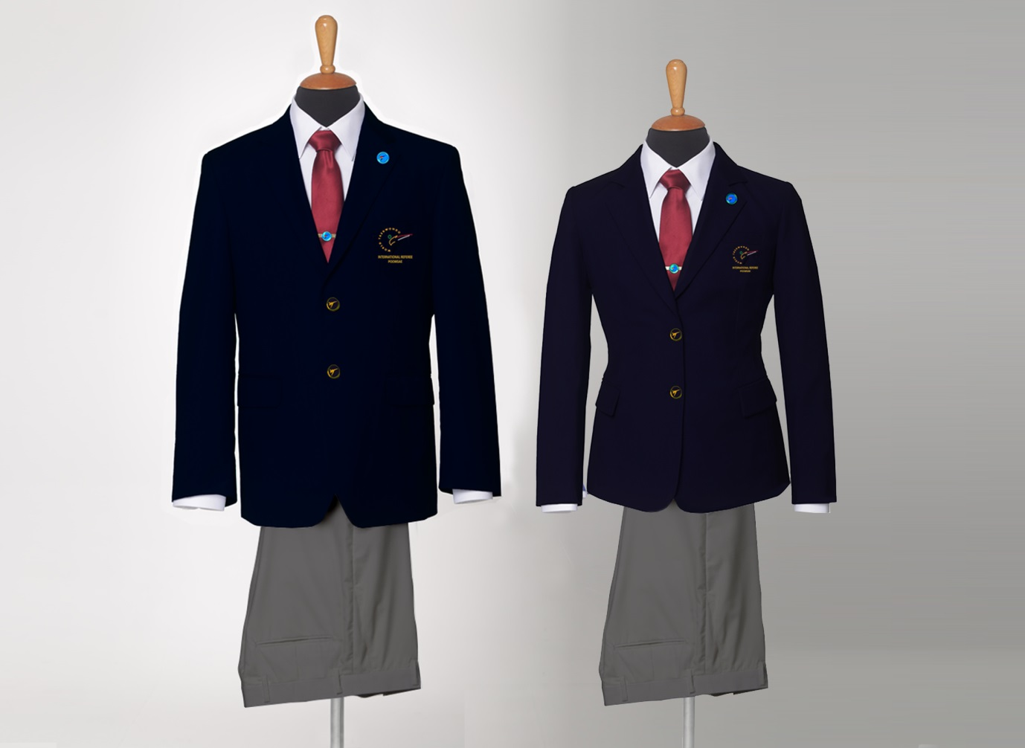

**\*IMPORTANT NOTICE!**

**Temporary application schedule for orders, production and delivery due to changes in the logo of the World Taekwondo Federation.**

* We will notify you in advance if any changes occur.
* The delivery period will vary depending on the situation in each country.  
   We are not responsible for delivery.
* Examples of ordering, production, and shipping have been described in an easy-to understand manner.   
  * Order : For a month  
  Ordering Period: June 19 - July 25.  
  * Manufacturing Time : For a month  
  Manufacture Period: August 1 - August 30.  
  * Shipping schedule : start September 7~.

**2017, May to July Ordering and Manufacture Period, Shipping Schedule**

**: Ordering and Manufacture Period, Shipping Schedule**

* **always Ordering and Manufacture Period is : Two Months**
* **First.** Order : For a month

Example) Ordering Period : January 1 - January 25

After the 25th orders will be included next month Order.

* **Second.** Manufacturing Time for WTF IR Uniform : For a month

Example) Manufacture Period: February 1 - February 25

* **Third.** Shipping schedule : Manufacturing month last day

Example) start March 7

* The shipping schedule may change depending on the production completion date.

If the shipping schedule is changed, it will be notified.

**1. Referee Uniform Detail**

* Jacket and Pants
* Long & Short Sleeved dress shirts
* Tie
* WTF Badge and Tie pin
* Suit cover with hanger
* Uniform Sets Price 320USD (Shipping and handling charges will add apply)

* The single products will be available individually with price on our website.

**2. Online shop and Contact**

* **On-line Shop :** [**www.wtf-ir.com**](http://www.wtf-ir.com)

**\*All products can only be purchased through online shop.**

* Contact Email : [re@wtf-ir.com](mailto:re@wtf-ir.com)
* Company : MJ SPORTS
* Address: 3rd Floor, Pyeongsan Building 434 Seongnae-dong, Gangdong-gu, Seoul, KOREA.
* Zip code : 05406
* T. +82(0)2 477 4055 / +82(0)70 7122 4066
* F. +82(0)2 477 4054
* Nearest subway station : Subway line No.5 - Dunchon Dong station
* Exit number : No. 3
* Our company opening Day of the week and hours are...

Monday to Friday from 10:00 am to 5:00 pm.

Lunch time: From 12:00 to 1:30

**3. Order Method**

* Go to www.wtf-ir.com (Follow the instructions on the website)
* All the referees can make a purchase. However, referees who have been appointed to 2016 WTF World Taekwondo Grand-Prix Final December in Baku, Azerbaijan will receive their uniform earlier. [Priority]
* Then, the delivery will be made in the order

**4. Payment Method**

* After confirmation of your order, you will be directed to the PayPal login page.
* Bank Transfer (Follow the instructions on the website)
* Shipping and handling charge will be included.
* The rules of our company. When you complete the payment, we can confirmation and it can produce your products.

**5. Shipping Info.**

* Please double check your order and shipping address.
* The items (Uniform) will be delivered an after ordering and Manufacture period. (after 55days ~ 60days)
* The rules of our company. When you complete the payment, we can confirmation and it can ship your

products.

* Please double check your order and shipping address.

**6. Return and Exchange Policy**

* **Online purchases made through MJ CO are valid for exchange, credit, or refund within 30 days from the delivery start date.**
* **We recommend using a carrier service that provides tracking.**
* **Please send us your products through EMS(international post office mail) or Fedex, UPS, ETC. Please note: only standard delivery services will be refunded.**

**Your return and invoice provide a postmark date that specifies the last day you have to return your merchandise by mail or to one of our stores.**

**You must contact our Customer Service department before mailing your returns.**

**If you would like to return your order by mail, please contact our Customer Service department.**

**by email : re@wtf-ir.com.**

**We will issue you a Return Authorization and give you further instructions.**

**Your online purchase cannot be returned in-store.**

**We are not able to accept blind returns.**

* **Change size or item due to mistake by the customer**

**: Buyer is responsible for the cost of replacing and returning goods ordered in buyer fault. You will be responsible for all return shipping fees.**

**We will not reimburse for original shipping.**

* **Not refund or exchange**

**: Items must be returned unwashed, unworn, undamaged products, undamaged package and with tags attached.**

**: Necktie, Badge and necktie pin must be in its original packaging.**

**: All returned items must be accompanied by the original ordered sheet and customs documents (if applicable).**

* **3. Refund or exchange in case**

**: Defective Product production, Defective Product subsidiary materials, Material defect. (Damaged, Defective, or Wrong Item(s))**

**We will refund the return shipping costs if a copy of the shipping receipt is attached to the Return Form.**

**Note that returns will be credited in the same currency and same exchange rate you as your original order.**