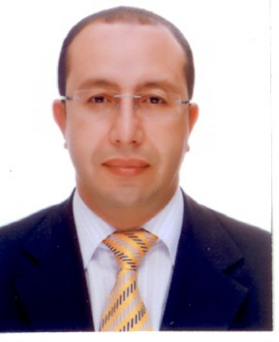

Welcome

Presidents and Secretaries General
WT Member National Associations

Dear taekwondo family members,

It is my great pleasure to welcome your National Association to participate in the 2017 WT World Taekwondo Grand-Prix Rabat 2017, which is scheduled for 22-23-24 September 2017 in Rabat, morocco

The Rabat event is very meaningful in that it will be the second Grand – Prix event leading up to the new Olympic cycle of the 2020 Tokyo Olympic Games.
I am confident that the Grand-Prix Rabat 2017 will feature the world’s best Taekwondo athletes, including Olympic and world champions, across eight different weight categories. Grand-Prix draws high interest from both international media and general public as it serves as a direct Olympic qualification event.

Moroccan Taekwondo family, will be honored to welcome you and your athletes, we strongly hope that you will enjoy the Grand Prix as well as the Great Stay awaiting you in Rabat , Morocco.

Sincerely yours,

Driss El Hilali
President of the Moroccan Royal Federation For Taekwondo

Accommodation / Transportation Guide
Hotel :

- The View Hotel
- Golden Tulip FARAH
- Rive Hotel
- Rihab Hotel
- Yasmine club Hotel

Airports :

- Rabat–Salé Airport (10 Km from the Capital city Rabat)
- Casablanca : Mohammed V International Airport (90 Km from the Capital City Rabat)

Conditions for Hotel reservations:

- deadline reservation : August the 31st, 2017
- The payment method : bank transfer or cash on arrival
Account Name :
FEDERATION ROYALE MAROCAINE DE TAEKWONDO
BANK NAME : BMCE BANK
SWIFT : BMCEMAMC
IBAM : 011 810 00 00 14 210 01 04898 90

Conditions for transportation reservation :

- Deadline reservation : Augst the 31st, 2017
- The ground transportation (Hotel – Venue- Hotel) will be provided free of charge ONLY for the teams who have reserved the hotel through the Organizing Committee.
- The Transportation (airoport – Hotel Hotel – Sport Venue , Sport Venue Hotel –airport) will be provided free of charge ONLY for teams who has reserved the hotel through the Organizing Committee.
- the contact person in charge of reservation :
Mr.LABLAN : +212 6 61 06 99 03 / / +212 6 61 19 46 38
frmtk@hotmail.com mtu.president@gmail.com

VISA INFORMATION

TO: Organizing Committee
THE MOROCCAN ROYAL TAEKWONDO FEDERATION
Av, ibnSina, siege des Federatim
ons, Rabat, Agdal, Maroc
Tel: +212 5 37 67 01 39
Fax: +212 5 37 67 02 06
frmtk@hotmail.com
mtu.president@gmail.com

Morocco Visa Information

The Organizing Committee can provide recommendation letters for visa applications. MNA’s are required to check the Moroccan visa application waiting times in their own countries and submit requests for recommendation letters to the Organizing Committee before October the 20th, 2015.
* remark: most of European countries and some countries from Asia and America do not have to obtain Visa Entries.

Citizens from countries who need Visa entries

For more information about the nearest Moroccan Embassy in your
Country, Please refer to these two hyper text links to have a clear image
on how proceed the Moroccan Visa entries:

https://www.diplomatie.ma/en/Accueil/tabid/2789/language/en-US/Default.aspx
http://www.learn4good.com/travel/morocco_embassies.htm
https://en.wikipedia.org/wiki/Visa_policy_of_Morocco#Visa_policy_map

Transportation

Rabat–Salé Airport

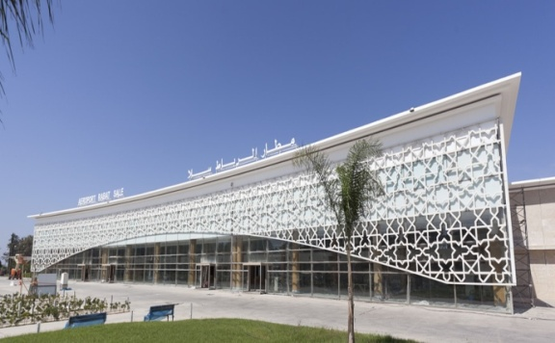
Salé Airport or Rabat–Salé Airport (IATA: RBA, ICAO: GMME) is an international airport located in the city of Salé, also serving Rabat, the [[[capital city]] of Morocco and of the Rabat-Salé-Kénitra region. It is a joint use public airport, also hosting the First Air Base of the Royal Moroccan Air Force. The airport is located about 7 kilometers (5 mi) east-northeast of Rabat the capital city of Morocco country and from the sport venue .

Mohammed V International Airport

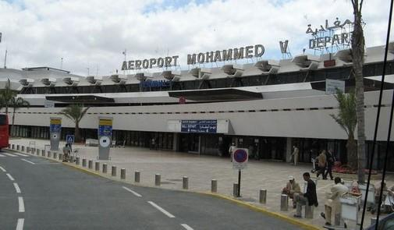
Mohammed V International Airport (French: Aéroport international Mohammed V, Arabic: مطار محمد الخامس الدولي‎‎, Matar Muhammad al-Khamis ad-Dowaly, IATA: CMN, ICAO: GMMN) is an international airport serving Casablanca, Morocco. Located in Nouaceur Province, it is operated by ONDA(National Airports Office). With just under 8 million passengers passing through the airport in 2014, it was the busiest airport in Morocco and the fourth busiest in Africa. In August 2014, ONDA reported a year-on-year increase of 7.28% passenger traffic, to 918,238. The airport serves as hub for Morocco's flag carrier Royal Air Maroc, Jetairfly, Air Arabia Maroc and RAM Express.
The airport is about 90 Km far from the sport venue.

World Taekwondo Grand Prix Rabat 2017

Arrival & Departure Form

TO: Organizing Committee
THE MOROCCAN ROYAL TAEKWONDO FEDERATION
Av, ibnSina, siege des Federations, Rabat, Agdal, Maroc
Tel: +212 5 37 67 01 39
Fax: +212 5 37 67 02 06
frmtk@hotmail.com
mtu.president@gmail.com

Please fill in the following enclosed form for your arrival and departure so we can handle your team at both airport s straight to the Hotel.
* Transportation provided only for teams with hotel reservations Organized By Organizing Committee.
Travel dates of team:
Country/Team
……………………………………………………………………………
Representative name (MNA)
……………………………………………………………………………
Tel.:…………………………………………………………….Mobile:………….…………………………………………..… Fax :…………………………………………………..……………… Email :…………………………………………………………

ARRIVAL
Airport | DATE | ARRIVAL TIME | FLIGHT NO. & AIRLINE COMP. | NUMBER OF PERSONS

DEPARTURE
Airport | DATE | DEPARTURE TIME | FLIGHT NO. & AIRLINE COMP. | NUMBER OF PERSONS

Signature of
The MNA President
Morocco Hotel Reservation Form

MNA TAEKWONDO: ……………………………………………………………
(The View Hotel) CATEGORY ***** STAR
Room Type | Arrival Date | Departure Date | No. of  NIGHTS | Number of  Rooms | Pricing  Per Night  Per Person | Total  Amount
Single |  |  |  |  | 210 Euro
Double |  |  |  |  | 120 Euro

(Golden Tulip Farah Hotel) CATEGORY ***** STAR:

Room Type | Arrival Date | Departure Date | No. of  NIGHTS | Number of  Rooms | Pricing  Per Night  Per Person | Total  Amount
Single |  |  |  |  | 125 Euro
Double |  |  |  |  | 75 Euro
TOTAL

(Rive Hotel) CATEGORY **** STAR

Room Type | Arrival Date | Departure Date | No. of  NIGHTS | Number of  Rooms | Pricing  Per Night  Per Person | Total  Amount
Single |  |  |  |  | 100 Euro
Double |  |  |  |  | 70 Euro
TOTAL

(RIHAB ) CATEGORY **** STAR

Room Type | Arrival Date | Departure Date | No. of  NIGHTS | Number of  Rooms | Pricing  Per Night  Per Person | Total  Amount
Single |  |  |  |  | 80 Euro
Double |  |  |  |  | 60 Euro
TOTAL

(Yasmine Hotel Club) CATEGORY **** STAR

Room Type | Arrival Date | Departure Date | No. of  NIGHTS | Number of  Rooms | Pricing Per Night Per Person | Total  Amount
Single |  |  |  |  | 70 Euro
Double |  |  |  |  | 50 Euro
TOTAL
Note: FOR ALL HOTELS: All price are in EURO or MAD equivalence currency and are per person and per night included ONLY BREAKFAST
Important Notice: This document must be returned to the Organizing Committee NO LATER THAN
August the 31st , 2017 to ensure appropriate transportation arrangements for your team.
Remark : * // there will be other 2* and 3* hotels depending on your choice in respected to the terms mentioned in the accommodation guide lines (see first page).

