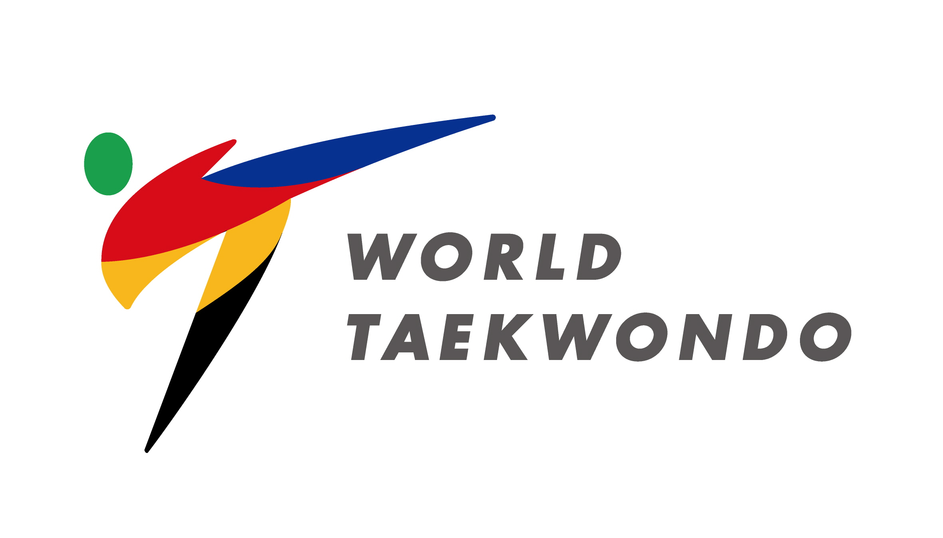

**Bid Registration**

|  |  |  |
| --- | --- | --- |
| **TO** | Sport & Event Management Department  World Taekwondo  E-mail: sport@worldtaekwondo.org | |
|  |  | |
| **FROM** |  | | |
|  | Name of Applying MNA or Applying City | | |
|  | |  | | |
| **EVENT** | |  | | |
| |  |  |  | | --- | --- | --- | | **YEAR** | **NAME OF EVENT(S) WISHING TO HOST** | **NAME OF HOST CITY** | |  |  |  | |  |  |  | |  |  |  | | | | | |

We hereby submit our bid registration for the World Taekwondo event(s) as above.

The completed bid file with the required attachments will be submitted to the World Taekwondo no later than 16 December 2022 to fulfill the application requirements.

|  |  |  |  |  |
| --- | --- | --- | --- | --- |
| **NAME** |  | | | |
|  | President of the Applying MNA or Mayor (or the equivalent) of the Applying City | | |
|  |  |  |  | |
| **DATE** |  | **SIGNATURE** |  | |